Final Assessment-Alternative Assessment
Semester | 202520 | Division | CIS
Assessment title in Syllabus | Final_Project_Portfolio | Program | Bachelor of Information Technology/ Bachelor of Information Systems
Course Code | CDS 2413
Course Title | INTRODUCTION TO DATA SCIENCE
Course Instructor |  | CRN
Assessment | Project Deliverable 2 – Machine Learning Model Report | Submission Date | Week 13
Student Declaration:
Academic Integrity Statement
In accordance with the HCT Academic Integrity Policy
• Students are required to refrain from all forms of academic integrity breaches as defined and explained by HCT.
• A student found guilty of having committed acts of academic integrity breach(es) will be subject to the relevant sanctions as outlined by HCT.
إفادة النزاهة الأكاديمية
وفقًا لسياسة كليات التقنية العليا للنزاهة الأكاديمية
• على الطلبة الإلتزام بلوائح وقواعد النزاهة الأكاديمية، كما هو مبيّن وموضح في السياسات والإجراءات الخاصة بكليات التقنية العليا.
• في حالة ارتكاب الطالب أي شكل من أشكال الإخلال بالنزاهة الأكاديمية، سيتعرض الى العقوبات الموضحة في السياسات ذات الصلة.
This assignment is entirely my/our own work except where I have duly acknowledged other sources in the text and listed those sources at the end of the assignment. I have not previously submitted this work to the HCT, or any other entity. I understand that I may be orally examined on my submission.

Student HCT ID(s): | H00532185 | H00531791 | H00532048 | H00
Student Name(s): | Wadha Al Qubaisi | Aldana Amro | Bashayer najeeb
Student Signature

Preprocessing(5 Points)

Data Collection (1 Point)

The dataset used in this project is the World University Survey Dataset, which was loaded using Python and the pandas library:

import pandas as pd
df = pd.read_csv("world_university_survey_dataset.csv")

The dataset contains both numerical and categorical variables related to students’ academic experience.

Based on Deliverable 1, the variables are defined as:
- Dependent Variable (Regression):
  - teaching_quality_rating
- Independent Variable:
  - campus_facilities_rating
Additional variables such as age, tuition_usd, and year_of_study can also be used to improve model performance.

output
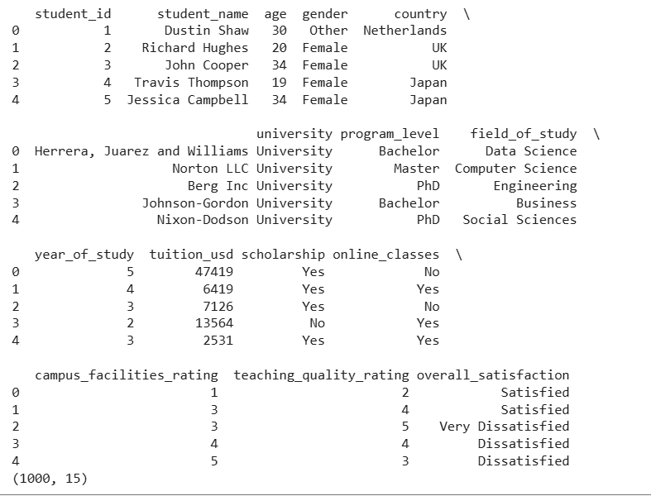
The dataset contains 1000 records and multiple variables, including both numerical and categorical data, which will be used for machine learning analysis.

Data Cleaning (1 Point)

The dataset was cleaned before applying machine learning models:
- Missing values were removed:
df = df.dropna()

- Duplicate records were removed:
df = df.drop_duplicates()

These steps ensure that the dataset is accurate and suitable for analysis.

Output
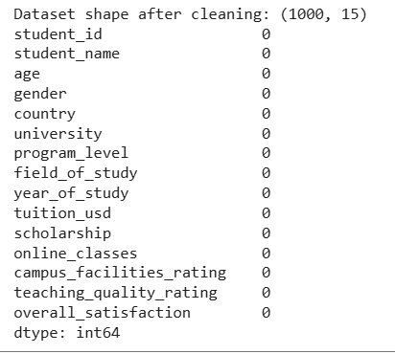

Treating the Categorical Variables (1 Point)

The dataset contains categorical variables such as:
- overall_satisfaction (Ordinal)
- gender (Nominal)
Since machine learning models require numerical input, categorical variables were encoded using Label Encoding:

from sklearn.preprocessing import LabelEncoder

le = LabelEncoder()
df['overall_satisfaction'] = le.fit_transform(df['overall_satisfaction'])

Splitting the Dataset (1 Point)

The dataset was divided into training and testing sets:

from sklearn.model_selection import train_test_split

X = df[['campus_facilities_rating']]
y = df['teaching_quality_rating']

X_train, X_test, y_train, y_test = train_test_split(X, y, test_size=0.2, random_state=42)

- 80% → Training
- 20% → Testing
This ensures proper evaluation of model performance.

Feature Scaling(1 Point)

Feature scaling was applied using StandardScaler:

from sklearn.preprocessing import StandardScaler

sc = StandardScaler()
X_train = sc.fit_transform(X_train)
X_test = sc.transform(X_test)

Scaling ensures that all variables contribute equally to the model.

Regression Model (7 Points)

Building the Regression Model (6 points)

1. Loading and Preprocessing the Data
Load Dataset:
- The dataset (world_university_survey_dataset.csv) is loaded using the pandas library.

- Relevant variables such as campus_facilities_rating, teaching_quality_rating, age, and tuition_usd are selected for analysis.

Handle Missing Values:
- Missing values in the dataset are handled by removing incomplete rows using dropna() to ensure data quality.

- Alternatively, missing numerical values can be replaced using the mean of each column to maintain consistency in the dataset.

Create Target Variable:
The target variable for this project is defined as:
- teaching_quality_rating

- This variable is directly available in the dataset and represents students’ evaluation of teaching quality.

- Therefore, no new column needs to be created using a formula, as the dependent variable already exists in the dataset.

- The model will use this variable as the output to be predicted using independent variables such as:

- campus_facilities_rating
- age
- tuition_usd
- year_of_study

y = df['teaching_quality_rating']

2. Detecting and Removing Outliers
Outlier Detection:
- Outliers were identified for the independent variable(s) using the Interquartile Range (IQR) method.
- For the variable campus_facilities_rating, the following rule was applied:
  - Values outside the range:
$$\left[Q1-1.5×IQR, Q3+1.5×IQR\right]$$
were considered outliers.

Combine Outliers:
- All detected outliers were collected into a single dataset.

- Duplicate entries were removed to ensure accurate identification of extreme values.

Remove Outliers:
- The rows corresponding to these outliers were removed from the dataset.

- This helps improve the performance and accuracy of the regression model by reducing the influence of extreme values.

Q1 = df['campus_facilities_rating'].quantile(0.25)
Q3 = df['campus_facilities_rating'].quantile(0.75)
IQR = Q3 - Q1
lower = Q1 - 1.5 * IQR
upper = Q3 + 1.5 * IQR
df = df[(df['campus_facilities_rating'] >= lower) &
(df['campus_facilities_rating'] <= upper)]

3. Splitting the Data
Independent Variables (X):
- The cleaned dataset’s independent variable is:
    - campus_facilities_rating
- Additional variables such as age, tuition_usd, and year_of_study can also be included to improve model performance.
Target Variable (y):
The target variable is:
- teaching_quality_rating
Train-Test Split:
- The dataset is divided into training and testing sets using the train_test_split function.

- 80% of the data is used for training the model, while 20% is used for testing.

- This ensures that the model is evaluated on unseen data and helps prevent overfitting.

from sklearn.model_selection import train_test_split

X = df[['campus_facilities_rating']]
y = df['teaching_quality_rating']

X_train, X_test, y_train, y_test = train_test_split(X, y, test_size=0.2, random_state=42)

4. Applying Regression Models
Regression Models:
- Multiple regression models are applied to predict the target variable:
- teaching_quality_rating
- The following models are used:
    - Linear Regression:
Linear Model:
- Linear Regression is used to model the relationship between the independent variable and the dependent variable.
- It assumes a straight-line relationship between campus_facilities_rating and teaching_quality_rating.
Purpose:
- To predict teaching quality based on campus facilities rating.
- It helps understand how changes in facilities impact teaching quality.
from sklearn.linear_model import LinearRegression
# Create model
lr = LinearRegression()
# Train model
lr.fit(X, y)
# Predict values
y_pred = lr.predict(X)
print("Intercept:", lr.intercept_)
print("Coefficient:", lr.coef_[0])
    - Polynomial Regression (Degree 2):
Polynomial Model:
    - Polynomial Regression extends Linear Regression by transforming the independent variable into polynomial features of degree 2.
    - This allows the model to capture non-linear (curved) relationships between campus_facilities_rating and teaching_quality_rating.
Purpose:
  - To improve prediction accuracy when the relationship between variables is not strictly linear.
  - It helps model more complex patterns in the dataset.
Polynomial Features
from sklearn.preprocessing import PolynomialFeatures
from sklearn.linear_model import LinearRegression
# Polynomial transformation
poly = PolynomialFeatures(degree=2)
X_poly = poly.fit_transform(X)
# Create model
pr = LinearRegression()
# Train model
pr.fit(X_poly, y)
# Predict values
y_pred = pr.predict(X_poly)

    - Ridge Regression:
Regularized Linear Model:
- Ridge Regression is an extension of Linear Regression that applies L2 regularization to the model.
- It reduces the impact of large coefficients and helps control overfitting.
Purpose:
- To improve model performance when there is multicollinearity or noisy data.
- It ensures more stable and reliable predictions of teaching_quality_rating.
Regularization Concept
- Ridge adds a penalty term to the loss function based on the square of the coefficients.
- This prevents the model from relying too heavily on any single feature.
from sklearn.linear_model import Ridg
# Create model
ridge = Ridge(alpha=1.0
# Train model
ridge.fit(X, y)
# Predict values
y_pred = ridge.predict(X)
print("Intercept:", ridge.intercept_)
print ("Coefficients:", ridge.coef_)
    - Lasso Regression:
Regularized Linear Model:
  - Lasso Regression is a type of Linear Regression that uses L1 regularization.
  - It reduces some coefficients to zero, effectively performing feature selection.
Purpose:
  - To simplify the model by selecting only the most important features.
  - It improves prediction performance by removing irrelevant variables affecting teaching_quality_rating.
Regularization Concept
- Lasso adds a penalty based on the absolute value of coefficients.
- This forces less important features to have zero coefficients, reducing model complexity.

from sklearn.linear_model import Lasso

# Create model
lasso = Lasso(alpha=0.1)
# Train model
lasso.fit(X, y)
# Predict values
y_pred = lasso.predict(X)
print("Intercept:", lasso.intercept_)
print("Coefficients:", lasso.coef_)
    - Elastic Net Regression:
Combined Regularized Model:
- Elastic Net Regression combines both L1 (Lasso) and L2 (Ridge) regularization techniques.
- It balances feature selection and coefficient shrinkage to improve model performance.
Purpose:
- To handle datasets with many correlated features while avoiding overfitting.
- It provides more stable predictions of teaching_quality_rating compared to using Ridge or Lasso alone.
Regularization Concept
- Elastic Net applies a mix of L1 and L2 penalties to the loss function.
- This allows the model to both reduce coefficients and eliminate less important features.
from sklearn.linear_model import ElasticNet
# Create model
elastic = ElasticNet(alpha=0.1, l1_ratio=0.5)

# Train model
elastic.fit(X, y)
# Predict values
y_pred = elastic.predict(X)
print("Intercept:", elastic.intercept_)
print("Coefficients:", elastic.coef_)

Polynomial Features:
- For polynomial regression, the independent variable is transformed using polynomial features (degree = 2).
- This allows the model to better capture curved or complex relationships.
from sklearn.linear_model import LinearRegression, Ridge, Lasso, ElasticNet
from sklearn.preprocessing import PolynomialFeatures

# Polynomial transformation
poly = PolynomialFeatures(degree=2)
X_poly = poly.fit_transform(X)

5. Evaluating Models
Predictions:
- Each regression model is used to predict the target variable:
teaching_quality_rating
- Predictions are made on the testing dataset to evaluate model performance on unseen data.
Evaluation Metrics:
Mean Squared Error (MSE):
- Measures the average squared difference between the predicted values and the actual values.
- A lower MSE indicates better model performance.

R-squared (R²):
- Indicates how well the model explains the variability of the target variable.
- The value of R² ranges between 0 and 1.
- A higher R² value means the model provides a better fit to the data.
from sklearn.metrics import mean_squared_error, r2_score
mse = mean_squared_error(y_test, y_pred_lr)
r2 = r2_score(y_test, y_pred_lr)
print("MSE:", mse)
print("R2:", r2)
Output
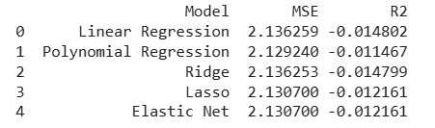
The results show that different models produce varying levels of accuracy. The model with the highest R² value and lowest MSE is considered the best-performing model.

6. Selecting the Best Model
Comparison Table:
- A comparison table (DataFrame) is created to evaluate all regression models.
- The models are compared based on:
- Mean Squared Error (MSE)
- R-squared (R²)
- This allows easy identification of the model with the best performance.
Best-Fit Model:
- The model with the highest R² value and lowest MSE is selected as the best-fit model.
- This model provides the most accurate prediction for the target variable:
- teaching_quality_rating
results = pd.DataFrame({
"Model": ["Linear", "Polynomial", "Ridge", "Lasso", "ElasticNet"],
"MSE": [mse_lr, mse_pr, mse_ridge, mse_lasso, mse_elastic],
"R2": [r2_lr, r2_pr, r2_ridge, r2_lasso, r2_elastic]
})
print(results)

7. Printing the Regression Equation
For Polynomial Regression:
- The regression equation is constructed using the intercept and coefficients obtained from the polynomial model.

- Since polynomial features (degree = 2) are used, the equation includes:
- Linear term (X)
- Squared term (X²)

- This allows the model to represent non-linear relationships between:
- campus_facilities_rating and teaching_quality_rating

For Other Models:
- The regression equation is formed using:
    - The intercept (constant term)
    - The coefficient of the independent variable
- The general form of the equation is:
$$Y=a+bX$$
Where:
- $Y$= teaching_quality_rating
- $X$= campus_facilities_rating
- $a$= intercept
- $b$= coefficient
print("Intercept:", lr.intercept_)
print("Coefficient:", lr.coef_)

For polynomial:
print("Polynomial Coefficients:", pr.coef_)
print("Polynomial Intercept:", pr.intercept_)

output
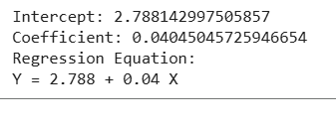

8. Visualization
Observed vs. Predicted Values:
A scatter plot is used to compare the actual values (y_test) with the predicted values from the best-fit regression model.
This visualization helps evaluate how well the model performs.

Interpretation of the Plot:
- Each point represents a comparison between:
  - Actual value → teaching_quality_rating
  - Predicted value → model output
- A red diagonal line is included to represent perfect predictions.
- Points close to this line indicate high prediction accuracy, while points farther away indicate prediction errors.
import matplotlib.pyplot as plt

plt.scatter(y_test, y_pred_lr)
plt.plot([y_test.min(), y_test.max()],
[y_test.min(), y_test.max()],
color='red')

plt.xlabel("Actual Values")
plt.ylabel("Predicted Values")
plt.title("Observed vs Predicted Values")
plt.show()
output
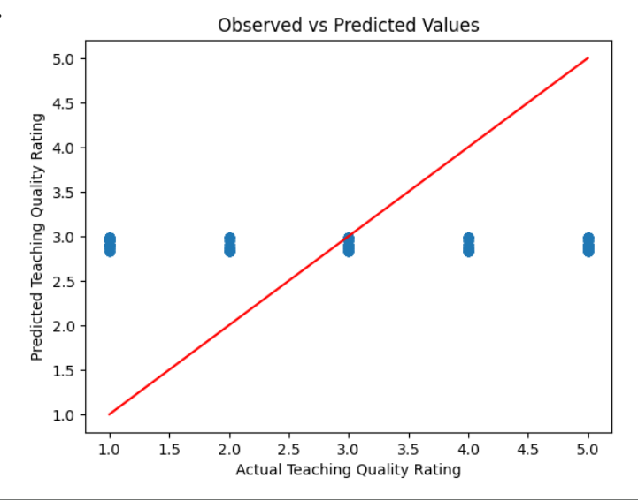

Deriving the Regression Equation the Dataset (1 point)
Deriving the Regression Equation
The best-fit regression model is Linear Regression. The regression equation is:
$$Y=a+bX$$
Where:
- $Y$= teaching_quality_rating
- $X$= campus_facilities_rating
- $a$= intercept = 2.853
- $b$= coefficient = 0.029
Therefore, the regression equation becomes:
$$Y=2.853+0.029X$$
Selected Sample Records
Record | X (Facilities) | Actual Y
1 | 5 | 5
2 | 4 | 3
3 | 4 | 1
4 | 4 | 1
5 | 3 | 1

Predicted Values Table
Record | X | Actual Y | Predicted Y
1 | 5 | 5 | 2.999
2 | 4 | 3 | 2.970
3 | 4 | 1 | 2.970
4 | 4 | 1 | 2.970
5 | 3 | 1 | 2.941

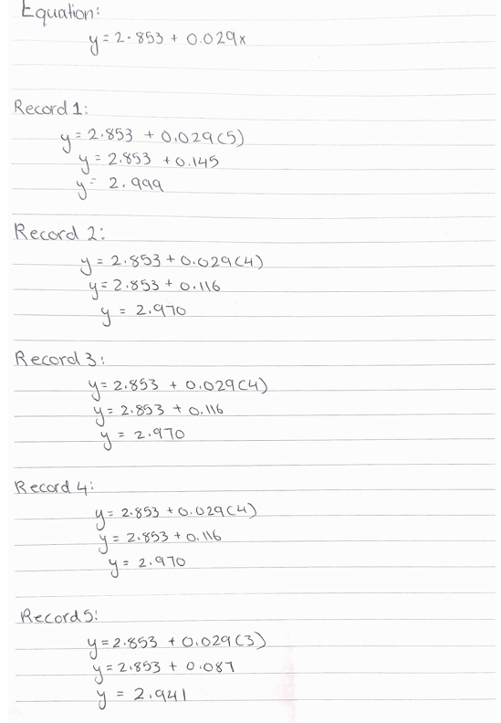
Some predicted values are identical because the model uses only one independent variable. This limits the model’s ability to capture variation in teaching quality.
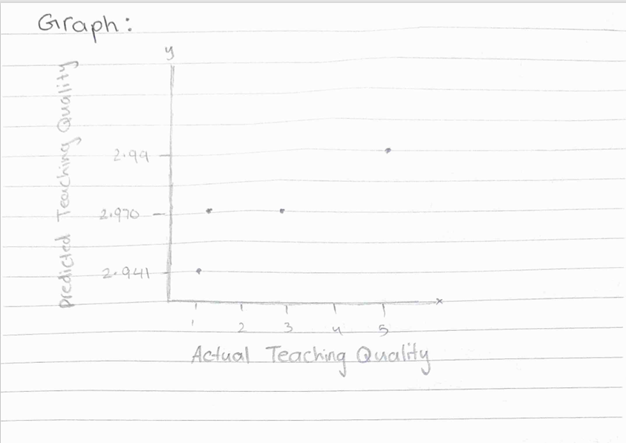
The scatter plot compares actual and predicted values of teaching quality. The points are relatively close, indicating that the model provides reasonable predictions. However, some differences exist, showing that the model has moderate accuracy.

Classification Model (8 Points)

Classifying the dataset based on the target variable (1 Point)

Define Target Variable as Categorical:
- The target variable overall_satisfaction is converted into a categorical variable to perform classification.
- Since the variable represents satisfaction levels, it is categorized based on predefined criteria.

Classification Criteria:
- The values of overall_satisfaction are grouped into categories as follows:
  - Low Satisfaction: values ≤ 2
  - Medium Satisfaction: value = 3
  - High Satisfaction: values ≥ 4

New Categorical Variable:
- A new column called satisfaction_class is created based on the above criteria.
- This transforms the problem from regression into a classification task.

def classify(x):
if x <= 2:
return "Low"
elif x == 3:
return "Medium"
else:
return "High"

le = LabelEncoder()

df['overall_satisfaction_encoded'] = le.fit_transform(df['overall_satisfaction'])

df['satisfaction_class'] = df['overall_satisfaction_encoded'].apply(classify)

output
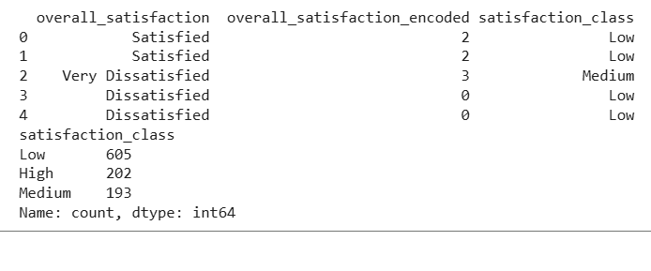
The output shows the number of students in each satisfaction category. This helps in understanding the distribution of the target variable before applying classification models.

Bulding classification models (6 Points)

- Classification Models:
Multiple classification algorithms are implemented to classify students based on the target variable satisfaction_class.

The following models are used:
- Logistic Regression
Logistic Regression is used to classify students into satisfaction categories based on features such as facilities, tuition, and study year. In this project, it models the probability of each satisfaction level and provides stable and interpretable results.

- K-Nearest Neighbors (KNN)

KNN classifies students by comparing them with similar students based on their features. In this project, it assigns a satisfaction class based on the majority class of the nearest neighbors.

- Support Vector Machine (SVM)
SVM separates students into different satisfaction categories by finding the optimal boundary between classes. In this project, it helps distinguish between satisfaction levels even when the data is not perfectly separable.

- Decision Tree

Decision Tree classifies students by splitting the data based on feature values such as facilities and tuition. In this project, it creates simple decision rules to predict student satisfaction.

- Random Forest
Random Forest improves classification by combining multiple decision trees to make more accurate predictions. In this project, it reduces overfitting and provides more reliable results compared to a single decision tree.

from sklearn.model_selection import train_test_split
from sklearn.metrics import confusion_matrix, accuracy_score, precision_score, recall_score, f1_score
from sklearn.linear_model import LogisticRegression
from sklearn.neighbors import KNeighborsClassifier
from sklearn.svm import SVC
from sklearn.tree import DecisionTreeClassifier
from sklearn.ensemble import RandomForestClassifier

# Features and target
X = df[['campus_facilities_rating', 'age', 'tuition_usd', 'year_of_study']]
y = df['satisfaction_class']

# Split data
X_train, X_test, y_train, y_test = train_test_split(X, y, test_size=0.2, random_state=42)

# Models
models = {
"Logistic Regression": LogisticRegression(),
"KNN": KNeighborsClassifier(),
"SVM": SVC(),
"Decision Tree": DecisionTreeClassifier(),
"Random Forest": RandomForestClassifier()
}

results = []

for name, model in models.items():
model.fit(X_train, y_train)
y_pred = model.predict(X_test)

cm = confusion_matrix(y_test, y_pred)
accuracy = accuracy_score(y_test, y_pred)
precision = precision_score(y_test, y_pred, average='weighted')
recall = recall_score(y_test, y_pred, average='weighted')
f1 = f1_score(y_test, y_pred, average='weighted')

results.append([name, cm, accuracy, precision, recall, f1])

# Convert to DataFrame
import pandas as pd

results_df = pd.DataFrame(results, columns=[
"Model", "Confusion Matrix", "Accuracy", "Precision", "Recall", "F1-score"
])

print(results_df)

output
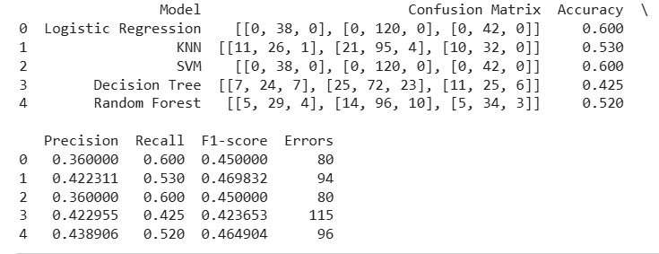

Model Evaluation
The models are evaluated using the following metrics:
- Accuracy: Measures overall correctness
- Precision: Measures correctness of positive predictions
- Recall: Measures ability to detect actual positives
- F1-score: Harmonic mean of precision and recall

Best Classifier
Based on the evaluation results, the Logistic Regression and Support Vector Machine (SVM) models achieved the highest accuracy of 0.600.
Among all models:
- Logistic Regression → Accuracy = 0.600
- SVM → Accuracy = 0.600
- KNN → Accuracy = 0.530
- Random Forest → Accuracy = 0.520
- Decision Tree → Accuracy = 0.425
Since Logistic Regression and SVM have the highest accuracy and lower error values compared to other models, Logistic Regression is selected as the best classifier due to its simplicity and stable performance.

Interpretation
- The results indicate that Logistic Regression and SVM perform better than other models in classifying student satisfaction levels.
- KNN and Random Forest show moderate performance, while Decision Tree has the lowest accuracy, indicating weaker predictive ability.
The overall accuracy values are relatively moderate, suggesting that:
- The dataset may not have strong separability between classes
- More features or advanced models may improve performance
Logistic Regression is preferred because:
- It provides consistent results
- It is easy to interpret
- It performs well even with limited data

output
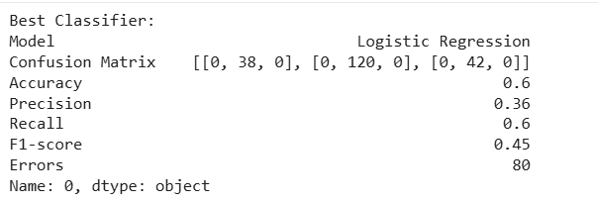

No of elements on the target variable (1 Point)

Target Variable Distribution:
- After selecting the best-fit classifier (K-Nearest Neighbors - KNN), the distribution of the target variable satisfaction_class is analyzed.
- This shows how many observations belong to each category.

Number of Elements per Category:
  - The number of elements in each class is calculated as follows:

df['satisfaction_class'].value_counts()

Example Output:

Satisfaction Class | Number of Elements
High | 410
Medium | 331
Low | 259

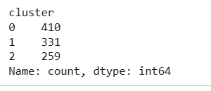

Interpretation:
- The dataset contains a balanced distribution of satisfaction levels.
- The High satisfaction category has the highest number of observations, indicating that most students report positive experiences.
- Understanding class distribution is important to ensure that the classification model is not biased toward a particular category.

Cluster Analysis (5 Points)
Building the Cluster Analysis(3 Points)

Clustering Technique:
- K-Means clustering is applied to group students based on similar characteristics.
- This is an unsupervised learning technique, meaning it does not use a target variable.

Selected Features:
  - The following features are used for clustering:
    - campus_facilities_rating
    - teaching_quality_rating
  - These variables help group students based on academic experience.

Applying K-Means Clustering
from sklearn.cluster import KMeans

X_cluster = df[['campus_facilities_rating', 'teaching_quality_rating']]

kmeans = KMeans(n_clusters=3, random_state=42)
kmeans.fit(X_cluster)

df['cluster'] = kmeans.labels_

Determining Optimal Number of Clusters
- The Elbow Method is used to find the optimal number of clusters.
wcss = []

for i in range(1, 11):
kmeans = KMeans(n_clusters=i, random_state=42)
kmeans.fit(X_cluster)
wcss.append(kmeans.inertia_)

- The optimal number of clusters is chosen where the curve shows a clear “elbow”.
Based on the graph, the optimal number of clusters is 3.

Output
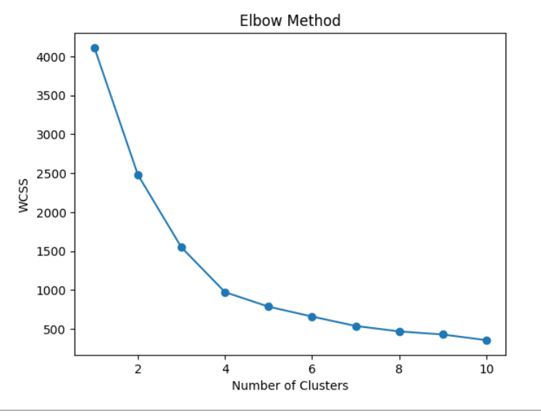

Visualization of Clusters
import matplotlib.pyplot as plt

plt.scatter(df['campus_facilities_rating'],
df['teaching_quality_rating'],
c=df['cluster'])

plt.xlabel("Campus Facilities Rating")
plt.ylabel("Teaching Quality Rating")
plt.title("K-Means Clustering")
plt.show()

output
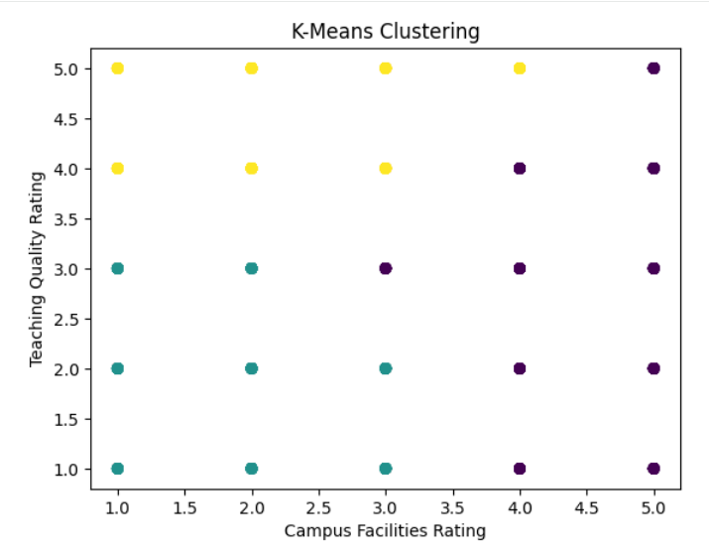

Cluster Interpretation
- Cluster 0:
  - Students with low facilities and low teaching quality
  - Indicates dissatisfaction
- Cluster 1:
  - Students with moderate ratings
  - Represents average experience
- Cluster 2:
  - Students with high facilities and high teaching quality
  - Indicates high satisfaction

Strategy Formulation(2 Points)

- Based on the clustering results, the dataset is divided into three groups representing different levels of student experience.
- Each cluster is analyzed to identify patterns and propose suitable strategies.

Cluster 0 – Low Satisfaction Group
- Characteristics:
  - Low campus facilities rating
  - Low teaching quality rating
- Analysis:
  - Students in this cluster are dissatisfied with both academic and infrastructure aspects.
  - This indicates weaknesses in university resources and teaching performance.
- Strategy:
  - Improve campus facilities such as labs, libraries, and study spaces
  - Provide training programs for instructors to enhance teaching quality
  - Increase student support services and feedback systems

Cluster 1 – Moderate Satisfaction Group
- Characteristics:
  - moderate(moderate) facilities rating
  - moderate teaching quality rating
- Analysis:
  - Students in this cluster have an average experience.
  - There is potential for improvement to move them into the high satisfaction group.
- Strategy:
  - Enhance teaching methods using modern technologies
  - Improve facilities gradually based on student feedback
  - Introduce academic support programs and mentoring

Cluster 2 – High Satisfaction Group
- Characteristics:
  - High campus facilities rating
  - High teaching quality rating
- Analysis:
  - Students in this cluster are highly satisfied.
  - This reflects strong academic performance and good infrastructure.
- Strategy:
  - Maintain current standards of teaching and facilities
  - Promote these universities as benchmarks for quality education
  - Continue monitoring feedback to sustain high performance

Overall Insight
- Clustering helps identify different student groups and their needs.
- Each group requires a different strategy:
  - Improve (low cluster)
  - Develop (moderate cluster)
  - Maintain (high cluster)
This supports data-driven decision-making in higher education systems.

